You May Be Eligible for Federal Rent Assistance!

The federal government is distributing billions of dollars in COVID-19 rental assistance through state and local programs around the country. If you’re having trouble paying your rent, utilities or other housing costs, we may be able to help you apply for benefits, charitable grants or other aid.

Who Is Eligible?
States and localities have established varying criteria for program eligibility. However, rent assistance funds are broadly available for those:
- Who have experienced a reduction in household income, incurred significant costs, or experienced a financial hardship due to COVID-19;
- Demonstrating a risk of losing their housing; and
- Meet certain income criteria specified by the program.

We encourage anyone experiencing a financial hardship to get more information about rent assistance - you may qualify.
What Does the Aid Cover?
Federal relief generally covers up to 12 months of rent, as back rent or future rent, paid up to three months at a time, depending on local rules and availability. Funds can also be used for:
- Utilities and home energy costs (e.g., electricity, gas, fuel oil, water and sewer, and trash removal.)
- Reasonable late fees (if not included in your rental or utility debt)
- Internet service to your home
- Moving expenses and other rental-related fees (such as security deposits, application fees, or screening fees) for families who have to move

How Does the Program Work?
Renters can apply for aid or apartment firms can apply on behalf of their residents. We encourage renters to reach out to their housing provider to see if they are participating in the program and are able to submit an application on your behalf. If they aren’t, you can still apply on your own.
How Do I Apply?
Programs that provide help with rent work in different ways, depending on how each state, local, or tribal government establishes its program. You may be able to apply for rental assistance yourself, or you may need to work with your landlord to submit the application
You can also find out where to apply for rental assistance in your area at https://www.consumerfinance.gov/renthelp/. If you can’t find a program in your area, call 2-1-1 or your local housing authority for assistance.

YOUR LOGO HERE
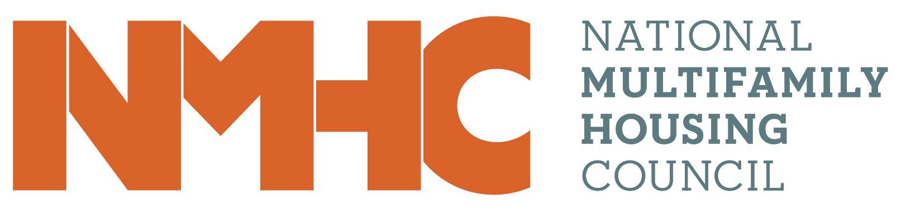
We remain committed to our residents during these trying times and understand how important it is to have stable housing during the pandemic.

